Demand Factor Analysis
Norbert Doerry
June 8, 2026
- Introduction
As described in DPC 310-1, demand factor analysis is a legacy method for determining the circuit load current for selecting cables feeding load centers (and power panels), for selecting the circuit breakers protecting the cable, and for determining the load center (and power panel) bus rating. While demand factor analysis is still available to be used, particularly in early stages of design, alternate techniques such as zonal load factor analysis and stochastic load analysis are preferred.
- Demand Factor Analysis
As stated in DPC 310-1:
“The analysis consists of calculating the connected load for each bus feeder by summing the connected load of all the loads attached to the bus feeder. Margin and service life allowances are applied to this sum to produce the bus feeder connected load. The bus feeder and the circuit breaker protecting the bus feeder shall have the capability to service a total load calculated by multiplying the bus feeder connected load expressed in amps with the demand factor from (Figure 1) for 450 volt AC systems or by multiplying the bus feeder connected load expressed in kW with the demand factor from (Figure 2) for other voltages or DC systems.”
The demand factor analysis method is attractive for its simplicity; loads need not be modeled beyond the information in the load list. The downside of this method is that it is purely empirical and may not provide a good estimate if the loads have behavior in the aggregate that differ from that normally encountered in shipboard systems.
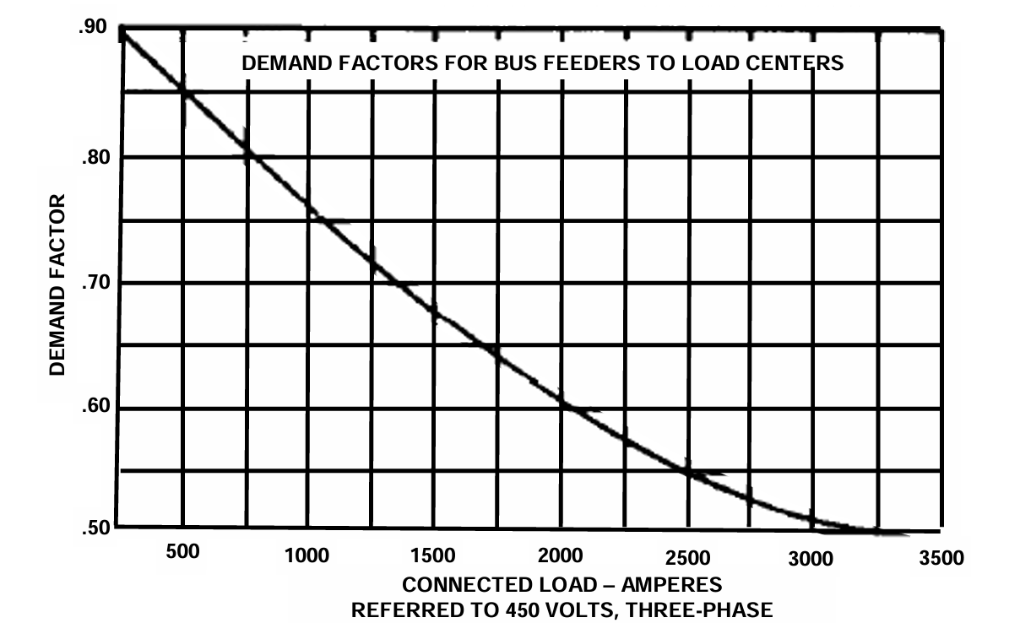
Figure 1: Demand Factor Curve (from MS 18299 via DPC 310-1)
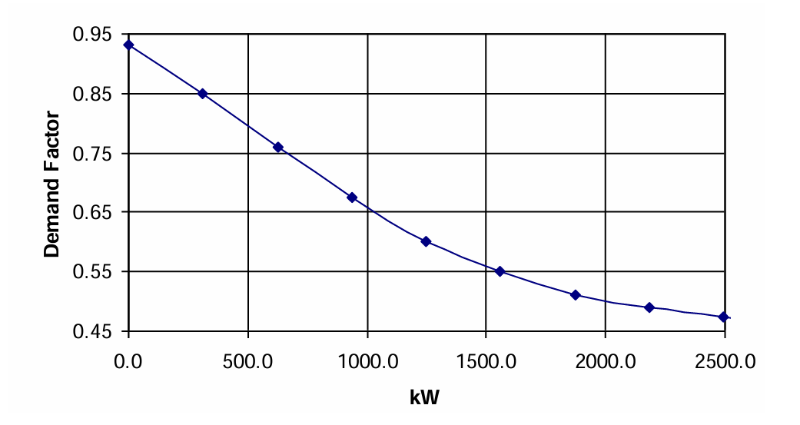
Figure 2: Demand factor curve based on connected load (from DPC 310-1)
- References
DPC 310-1 Electric Power Load Analysis (EPLA) for Surface Ships

